Document Study Test: The Great Depression in the USA/SOURCES
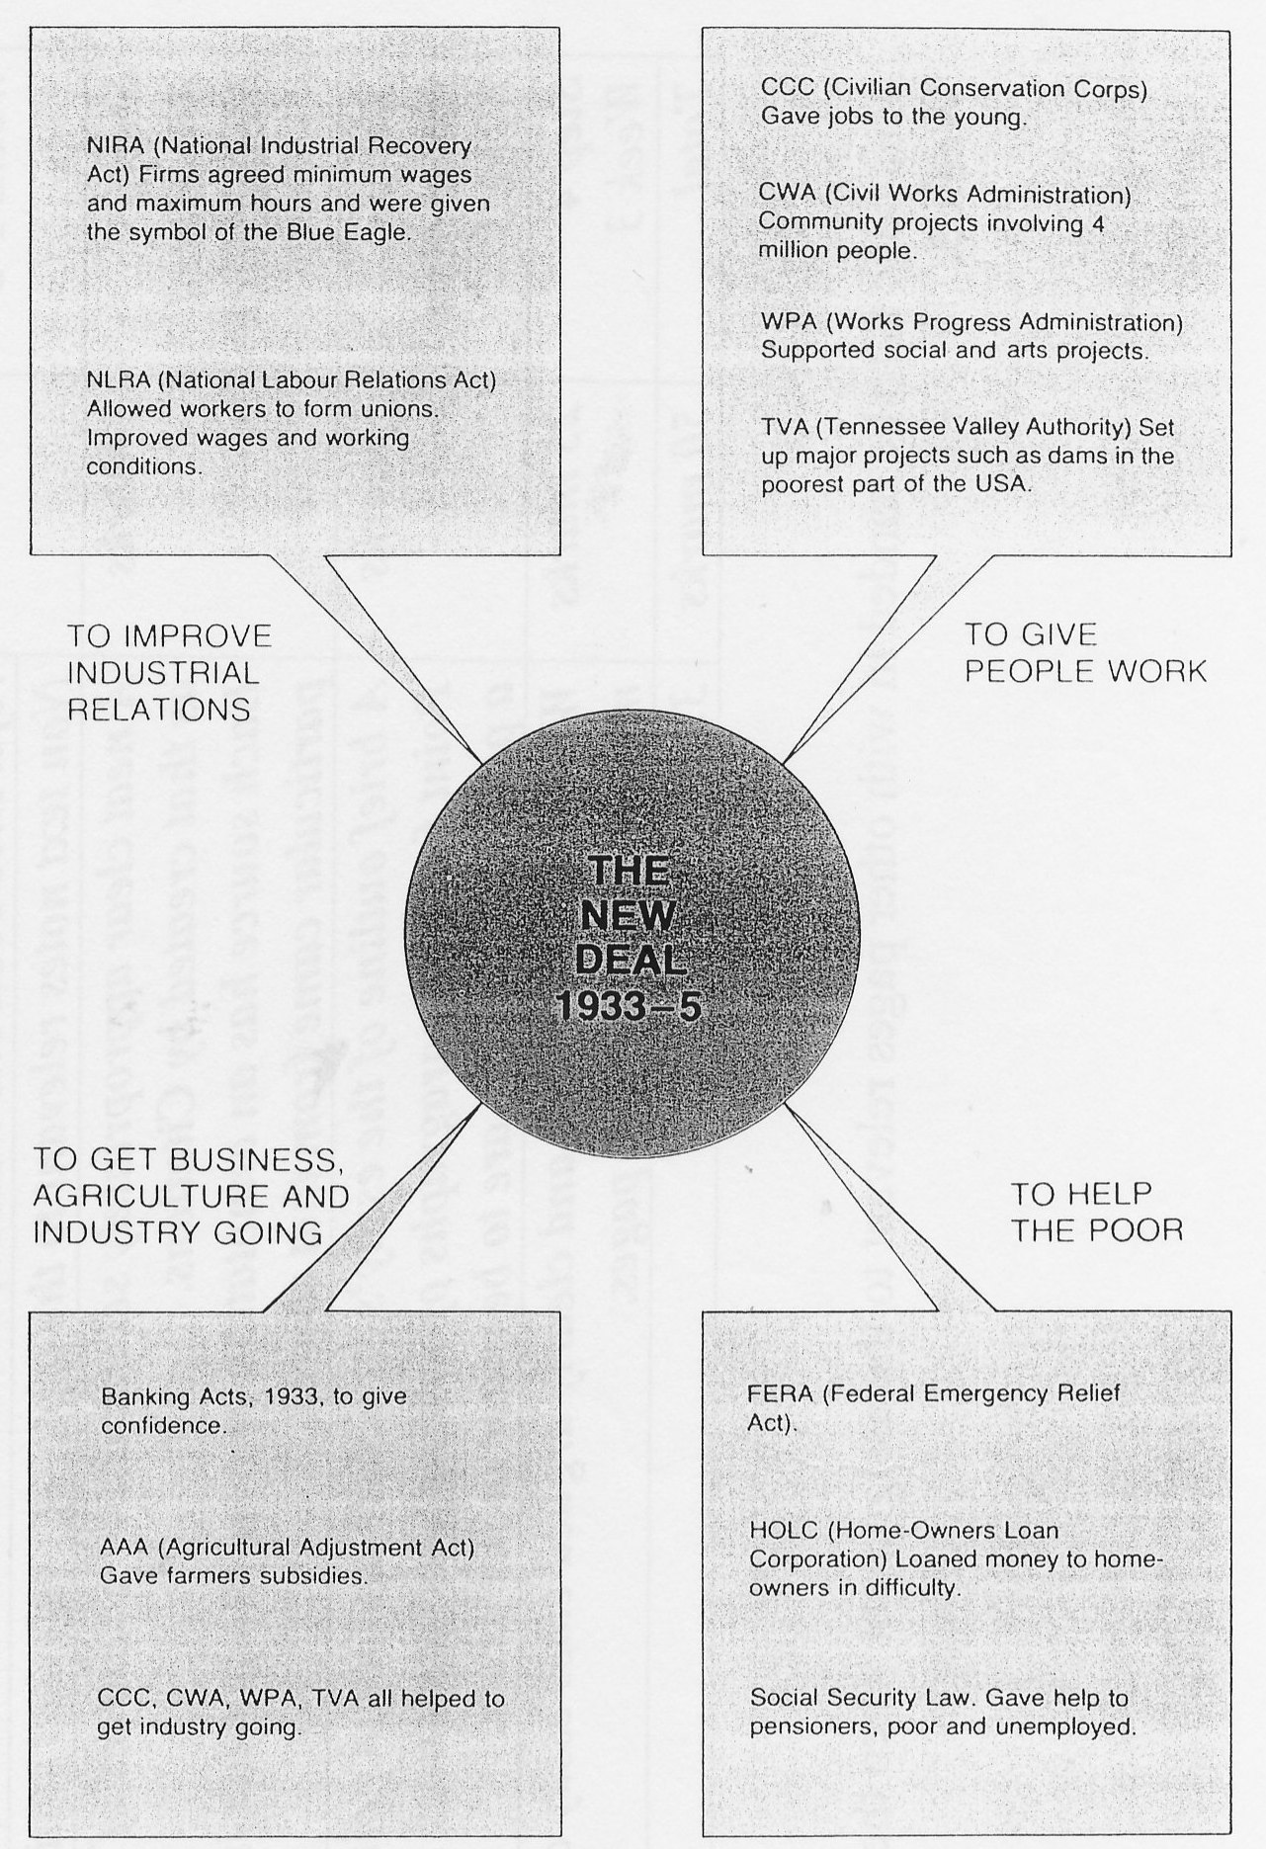

SOURCE 1:

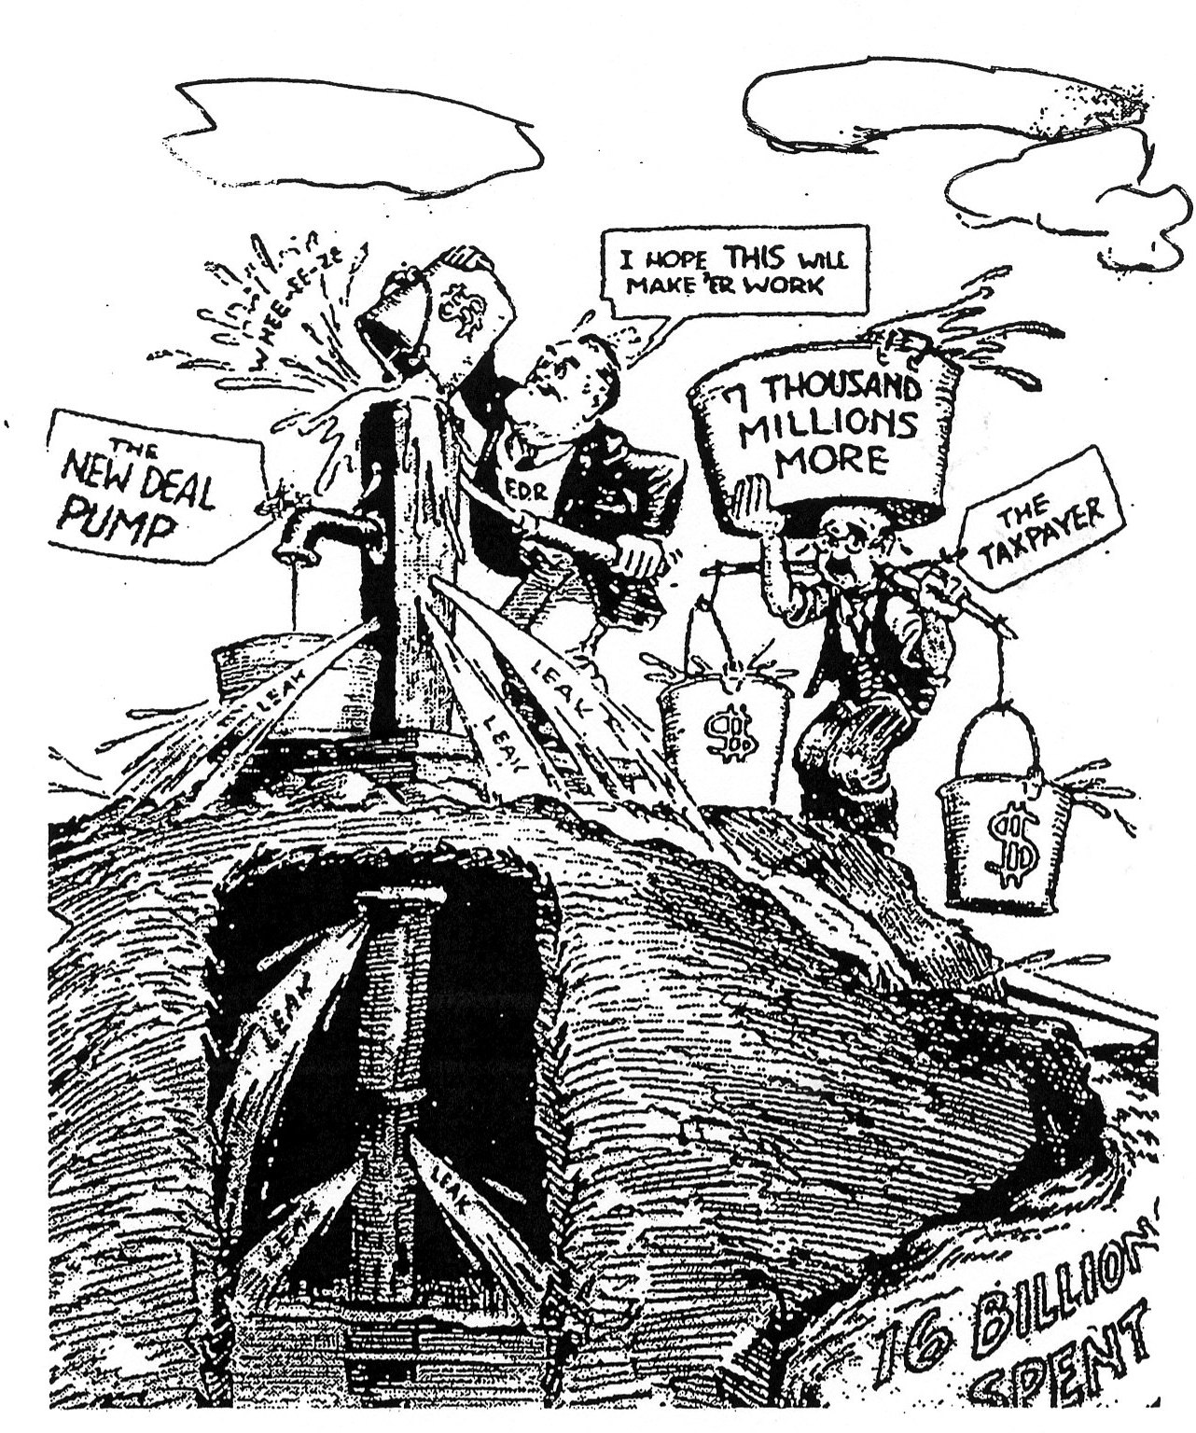

SOURCE 2: USA Cartoon 1934

SOURCE 3:

A conservative view of the effectiveness of The New Deal policies is taken by journalist and historian Steve Wiegand: S.Wiegand(2001), US History, IDG, New York, p.225
“How well the New Deal actually worked is debatable. Many of the programs had big price tags. The National Debt, which was about $22.5 billion when FDR took office, was nearly double that by 1940, and so was the size of the federal bureaucracy. Moreover, millions of people were still out of work.
What is undebatable is the fact that the New Deal had greatly increased the role of the federal government in people’s lives. And most people felt a lot better in 1940 than they did in 1932. Americans were pleased enough in fact with FDR’s performance by 1940 to give him what they had given no other president-a third term.”

GNP (Gross National Product), 1929-1941 ($ US billion)

Year | 1929 | 1930 | 1931 | 1932 | 1933 | 1934 | 1935 | 1936 | 1937 | 1938 | 1939 | 1940 | 1941
GNP | 14.4 | 91.1 | 76.3 | 58.5 | 56 | 65 | 72.5 | 82.5 | 90.8 | 85.2 | 91.1 | 100.6 | 125.8

SOURCE 4:

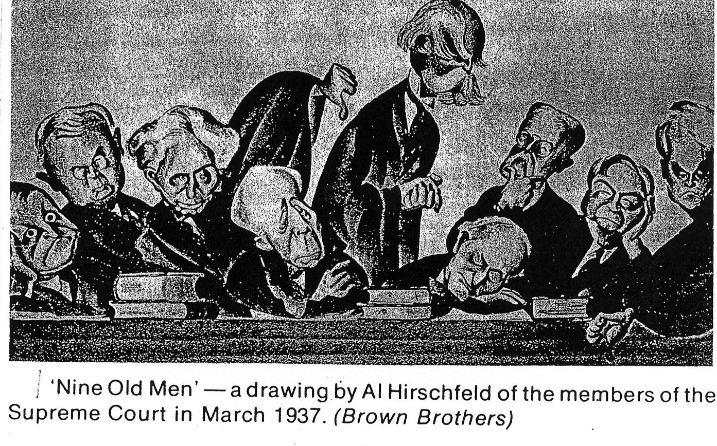

SOURCE 5:

A British Cartoon from PUNCH in June 1935

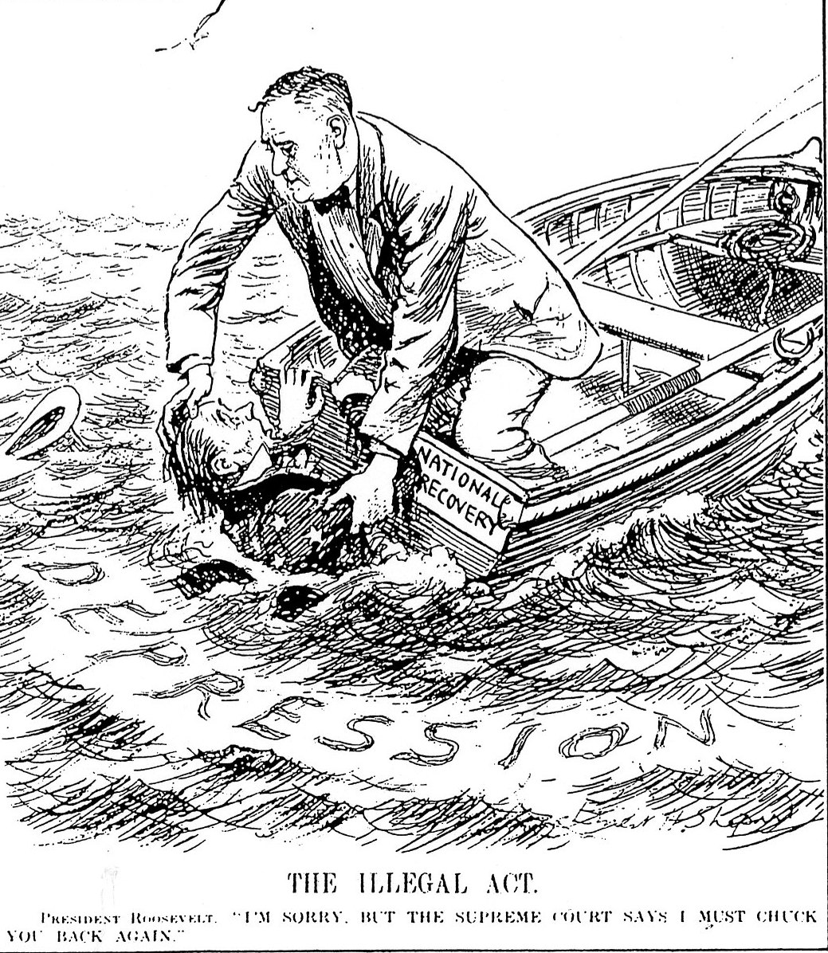

Document Study Test: The Great Depression in the USA/Questions NAME:___________________________________

1. Consider source 1. Choose two agencies designed to create jobs and explain what they were called and what they did. (2 marks)
__________________________________________________________________________________________________________________________________________________________________________________________________________________________________________________________________________________________________________________________________________________________________________________________________________________________________________________________________________________________________________________________________________________________________________________________________________________________________________________________________________________________________________________________________________

2. What were NIRA and NLRA designed to do? Explain in detail. (3 marks)
__________________________________________________________________________________________________________________________________________________________________________________________________________________________________________________________________________________________________________________________________________________________________________________________________________________________________________________________________________________________________________________________________________________________________________________________________________________________________________________________________________________________________________________________________________

3. Study source 2. This cartoon represents a perspective or point of view of the New Deal. Identify the main characters and discuss four criticisms of the New Deal as displayed in the cartoon. Refer to elements (parts) of the cartoon in your answer. (4 marks)
__________________________________________________________________________________________________________________________________________________________________________________________________________________________________________________________________________________________________________________________________________________________________________________________________________________________________________________________________________________________________________________________________________________________________________________________________________________________________________________________________________________________________________________________________________
____________________________________________________________________________________________________________________________________________________________________________________________________________

4. Is this a primary or secondary source? What is the attitude/belief of Weigand? Do you think this is a fair approach from Wiegand given the growth in Gross National Product? Explain your answer. (4 marks)
__________________________________________________________________________________________________________________________________________________________________________________________________________________________________________________________________________________________________________________________________________________________________________________________________________________________________________________________________________________________________________________________________________________________________________________________________________________________________________________________________________________________________________________________________________
__________________________________________________________________________________________________________________________________________________________________________________________________________________________________________________________________________________________________________________________________________________________________________________________________________________________________________________________________________________________________________________________________________________________________________________________________________________________________________________________________________________________________________________________________________

5. In source 4, do you think the cartoonist and Roosevelt share the same attitude about members of the Supreme Court? What is the message of this cartoon? (4 marks)
__________________________________________________________________________________________________________________________________________________________________________________________________________________________________________________________________________________________________________________________________________________________________________________________________________________________________________________________________________________________________________________________________________________________________________________________________________________________________________________________________________________________________________________________________________

6.What is the context (who, what ,where, when, why…?) of source 5?What was the illegal act referred to in the cartoon? Do you think this cartoon supports or opposes the New Deal? Refer to the cartoon in your answer. (6 marks)
__________________________________________________________________________________________________________________________________________________________________________________________________________________________________________________________________________________________________________________________________________________________________________________________________________________________________________________________________________________________________________________________________________________________________________________________________________________________________________________________________________________________________________________________________________
__________________________________________________________________________________________________________________________________________________________________________________________________________________________________________________________________________________________________________________________________________________________________________________________________________________________________________________________________________________________________________________________________________________________________________________________________________________________________________________________________________________________________________________________________________

7. What value do you think these cartoons hold for historians today? Explain your answer. (2 marks)
________________________________________________________________________________________________________________________________________________________________________________________________________________________________________________________________________________________________________________________________________________________________________________________________________________________

